**Project Design Phase II**

**Data Flow Diagram & User Stories**

|  |  |
| --- | --- |
| Date | 6 March 2025 |
| Team ID | SWTID1741243418148473 |
| Project Name | FitFlex |
| Team Leader | FAMITHA S B |
| Team Member 1 | HARINI M |
| Team Member 2 | VARSHINI VR |
| Team Member 3 | JANANI M S |
| Team Member 4 | SATHVIKA E |
| Maximum Marks | 4 Marks |

**Data Flow Diagrams:**

A Data Flow Diagram (DFD) is a traditional visual representation of the information flows within a system. A neat and clear DFD can depict the right amount of the system requirement graphically. It shows how data enters and leaves the system, what changes the information, and where data is stored.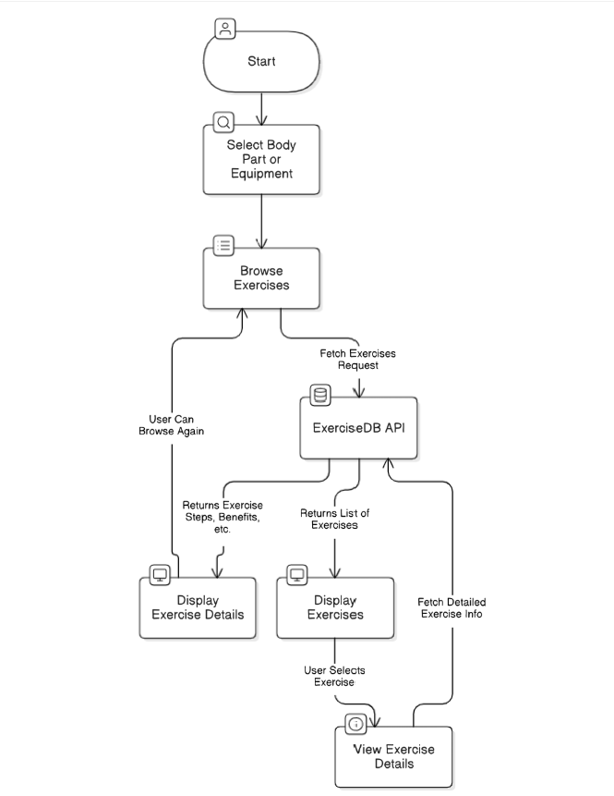

1. The User selects a body part or equipment.
2. The request is sent to Browse Exercises, which fetches relevant data from ExerciseDB API.
3. The API returns a list of exercises, which is displayed to the User.
4. The User selects a specific exercise, triggering the View Exercise Details process.
5. The ExerciseDB API provides detailed exercise information.
6. The app displays the details, and the User can either browse more exercises or select another one.

**User Stories:**

| **User Type** | **User Story Number** | **User Story / Task** | **Acceptance criteria** | **Priority** | **Release** |
| --- | --- | --- | --- | --- | --- |
| Customer (Web User) | USN-1 | As a User, I can browse exercises by selecting a body part. | I can see a list of exercises related to the selected body parts. | High | Sprint-1 |
| Customer (Web User) | USN-2 | As a user, I can browse exercise by selecting equipment. | I can see a list of exercises related to the selected equipment. | High | Sprint-1 |
| Customer (Web User) | USN-3 | As a user, I view detailed explanations about exercise. | I can see exercise images, steps and target muscles | High | Sprint-1 |
| Customer (Web User) | USN-4 | As a user, I can see related Youtube videos. | I can navigate to the related videos on Youtube. | Low | Sprint-2 |
| Customer (Web User) | USN-5 | As a user, I can easily navigate to the home page. | I can click the home button and return to the home page. | High | Sprint-1 |

**Project Design Phase-II**

**Solution Requirements (Functional & Non-functional)**

|  |  |
| --- | --- |
| Date | 6 March 2025 |
| Team ID | SWTID1741243418148473 |
| Project Name | FitFlex |
| Team Leader | FAMITHA S B |
| Team Member 1 | HARINI M |
| Team Member 2 | VARSHINI VR |
| Team Member 3 | JANANI M S |
| Team Member 4 | SATHVIKA E |
| Maximum Marks | 4 Marks |

**Functional Requirements:**

Following are the functional requirements of the proposed solution.

|  |  |  |
| --- | --- | --- |
| **FR No.** | **Functional Requirement (Epic)** | **Sub Requirement (Story / Sub-Task)** |
| FR-1 | Browsing Exercises | Browse Exercise by Body Parts  Browse Exercise by Equipment  Browse Exercise by Popular |
| FR-2 | Exercise Details | View exercise GIF, Target muscles, secondary muscles.  Confirmation via OTP |
| FR-3 | User Experience | Navigate Back to Home page. |

**Non-functional Requirements:**

Following are the non-functional requirements of the proposed solution.

|  |  |  |
| --- | --- | --- |
| **FR No.** | **Non-Functional Requirement** | **Description** |
| NFR-1 | **Usability** | The User Interface (UI) should be easy to navigate for all users of all skill levels. |
| NFR-2 | **Security** | API requests must be secure. |
| NFR-3 | **Reliability** | The system should handle API failures gracefully. |
| NFR-4 | **Performance** | The application should load data quickly. |
| NFR-5 | **Availability** | The system should maintain an uptime of at least 99.9%, ensuring accessibility across different time zones. |
| NFR-6 | **Scalability** | The app should handle increasing numbers of users and concurrent streams efficiently without performance degradation. The architecture should support future feature expansion. |

**Project Design Phase-II**

**Technology Stack (Architecture & Stack)**

|  |  |
| --- | --- |
| Date | 6 March 2025 |
| Team ID | SWTID1741243418148473 |
| Project Name | FitFlex |
| Team Leader | FAMITHA S B |
| Team Member 1 | HARINI M |
| Team Member 2 | VARSHINI VR |
| Team Member 3 | JANANI M S |
| Team Member 4 | SATHVIKA E |
| Maximum Marks | 4 Marks |

**Technical Architecture:**

The Deliverable shall include the architectural diagram as below and the information as per the table1 & table 2

|  |  |  |  |
| --- | --- | --- | --- |
| **S.No** | **Component** | **Description** | **Technology** |
|  | User Interface | How user interacts with application | ReactJS, CSS, React Fa icons |
|  | Application Logic-1 | Logic for fetching and displaying data | JavaScript, ReactJS |
|  | Application Logic-2 | API requests handling and error handling | Axios for HTTP requests |
|  | External API-1 | Fetching ExerciseDB data | ExerciseDB API (via RapidAPI) |

**Table-2: Application Characteristics:**

| **S.No** | **Characteristics** | **Description** | **Technology** |
| --- | --- | --- | --- |
|  | Open-Source Frameworks | List the open-source frameworks used | ReactJS, Axios |
|  | Security Implementations | Securing API calls and access controls | HTTPS, API key authentication (RapidAPI) |